****Hafiza Laiba****

****F2023266320****

****V-20****

****Software Engineering****

### ****1. Introduction****

#### ****1.1 Purpose****

The purpose of this document is to provide a detailed Software Requirements Specification (SRS) for the Online Job Seeker Software. The system aims to connect job seekers with potential employers through an intuitive platform that allows job seekers to search and apply for jobs, while employers can post job openings and manage applicants.

#### ****1.2 Scope****

The Online Job Seeker Software is a web-based platform that offers job listings, job applications, user profiles, and management tools for employers. It is designed to improve the efficiency of job searching and recruitment processes, providing a seamless experience for both job seekers and employers.

#### ****1.3 Definitions, Acronyms, and Abbreviations****

* **Job Seeker**: An individual who is looking for job opportunities.
* **Employer**: An organization or individual looking to hire employees.
* **SRS**: Software Requirements Specification.
* **UI**: User Interface.
* **Database**: A structured set of data stored electronically.
* **Admin**: The person managing the overall system.

### ****2. System Overview****

#### ****2.1 Product Perspective****

The Online Job Seeker Software is a web application that provides job seekers with access to job listings and tools to apply for jobs, while allowing employers to post job vacancies and manage applications. The system will consist of:

* A **Job Seeker Interface** where users can browse jobs, create profiles, and apply.
* An **Employer Interface** where employers can post jobs, review applicants, and manage job postings.
* An **Admin Interface** to manage system functionalities, users, and job listings.

#### ****2.2 User Classes and Characteristics****

* **Job Seekers**: These users will have access to search for jobs, apply for them, and manage their resumes.
* **Employers**: These users will be able to post job listings, view job applications, and manage recruitment.
* **Admins**: These users will manage all system operations, monitor user activity, and ensure the platform's smooth functioning.

#### ****2.3 Operating Environment****

The Online Job Seeker Software will operate on modern web browsers such as Google Chrome, Firefox, and Safari. The system will be hosted on a cloud server to ensure scalability and availability.

### ****3. Functional Requirements****

#### ****3.1 Job Seeker Features****

* **Profile Management**: Job seekers can create, update, and delete their profiles.
* **Job Search**: Users can search jobs based on criteria like location, skills, salary range, etc.
* **Job Application**: Job seekers can apply for jobs, attach resumes, and track their application status.

#### ****3.2 Employer Features****

* **Job Posting**: Employers can post job openings with detailed descriptions.
* **Application Management**: Employers can review applications, shortlist candidates, and schedule interviews.
* **User Management**: Employers can create and manage accounts for job postings.

#### ****3.3 Admin Features****

* **User Management**: Admin can manage job seeker and employer accounts.
* **Job Listing Monitoring**: Admin can monitor and approve or reject job listings.
* **System Reports**: Admin can generate reports on system activity, user engagement, etc.

### ****4. Non-Functional Requirements****

#### ****4.1 Performance Requirements****

* The system should be able to handle up to 1000 simultaneous users.
* The page load time should not exceed 3 seconds.

#### ****4.2 Security Requirements****

* User data must be encrypted using secure protocols.
* Only authorized users (admins) can access sensitive data.

#### ****4.3 Usability Requirements****

* The user interface should be intuitive and easy to navigate.
* The platform should be mobile-responsive.

### ****5. System Design****

#### ****5.1 Use Case Diagram****

A use case diagram visualizes the interaction between users (job seekers, employers, admins) and the system’s functionalities.

* **Actors**: Job Seeker, Employer, Admin
* **Use Cases**: Create Profile, Post Job, Apply for Job, Manage Applications, etc.

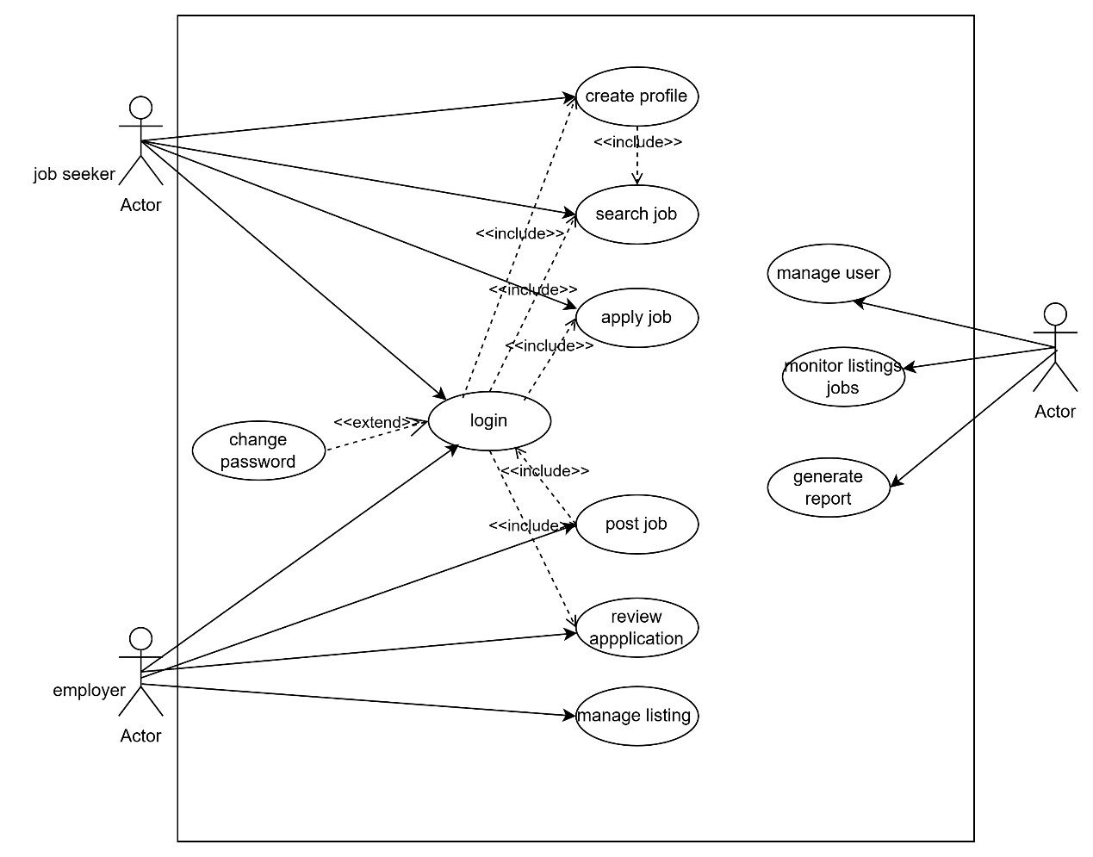

#### ****5.2 ERD (Entity-Relationship Diagram)****

The ERD outlines the data entities and their relationships within the system. It will represent entities such as **User**, **Job**, **Employer**, **Job Application**, etc.

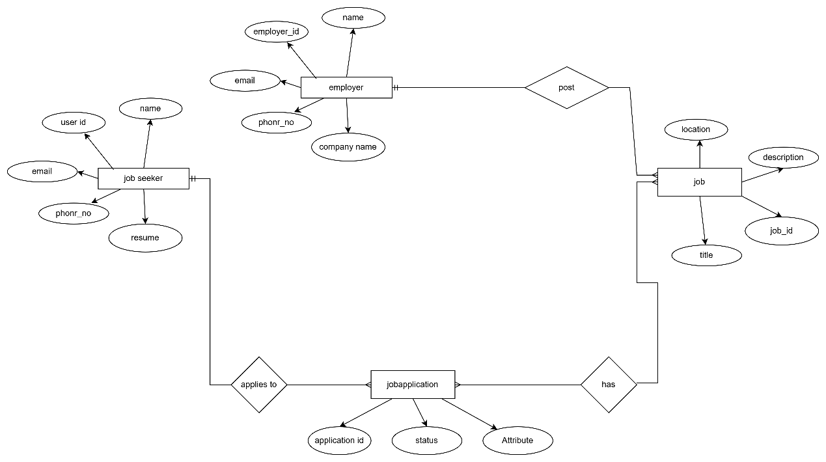

#### ****5.3 State Diagram****

The state diagram will show the different states a **Job Application** can go through, such as **Pending**, **Accepted**, **Rejected**, etc.

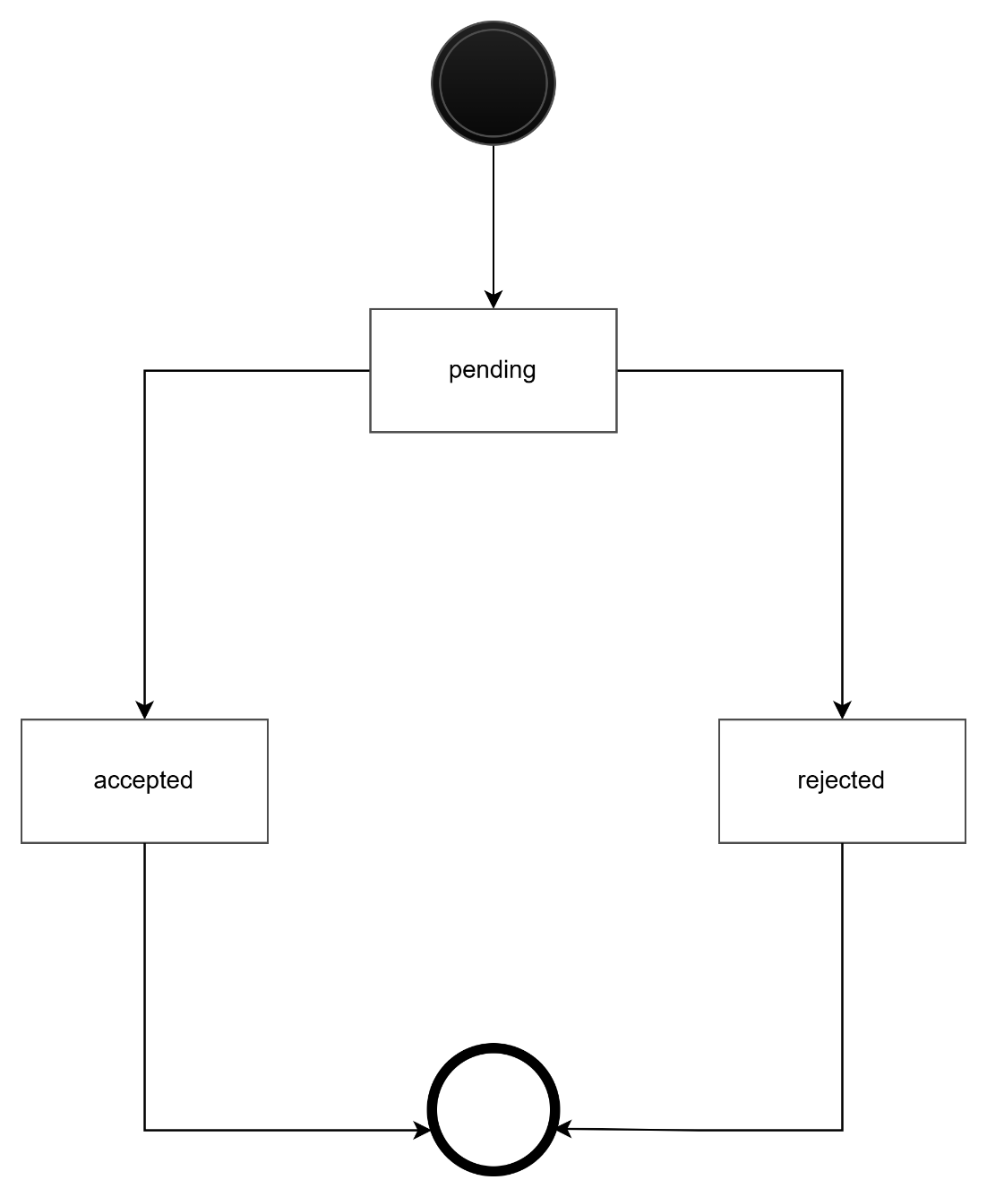

#### ****5.4 Activity Diagram****

An activity diagram will illustrate the flow of activities involved in the **Job Search and Application Process**.

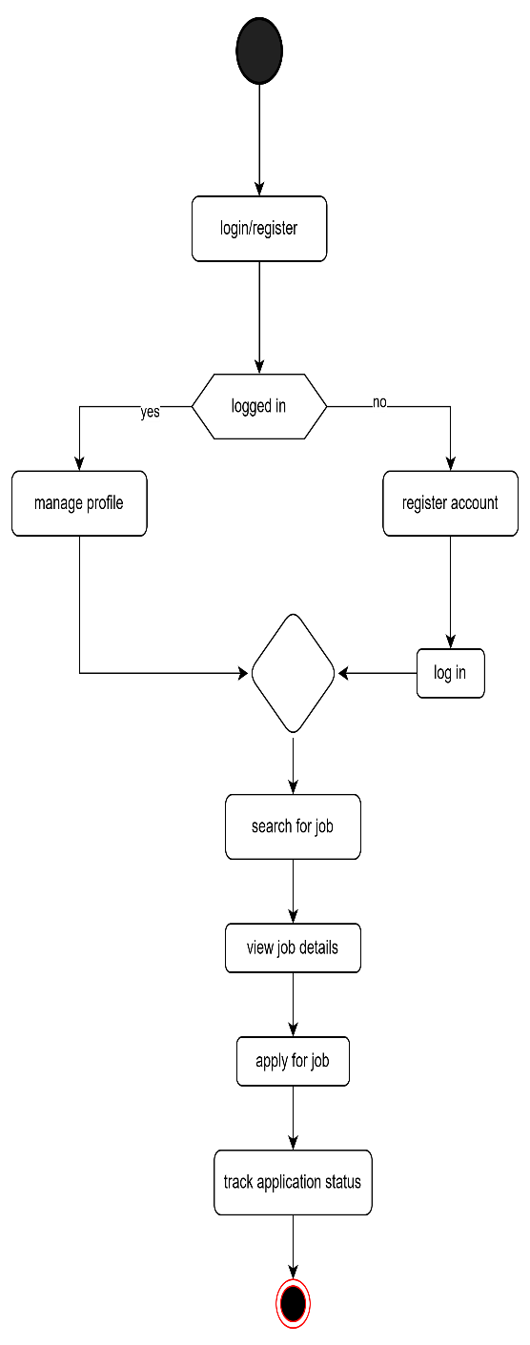 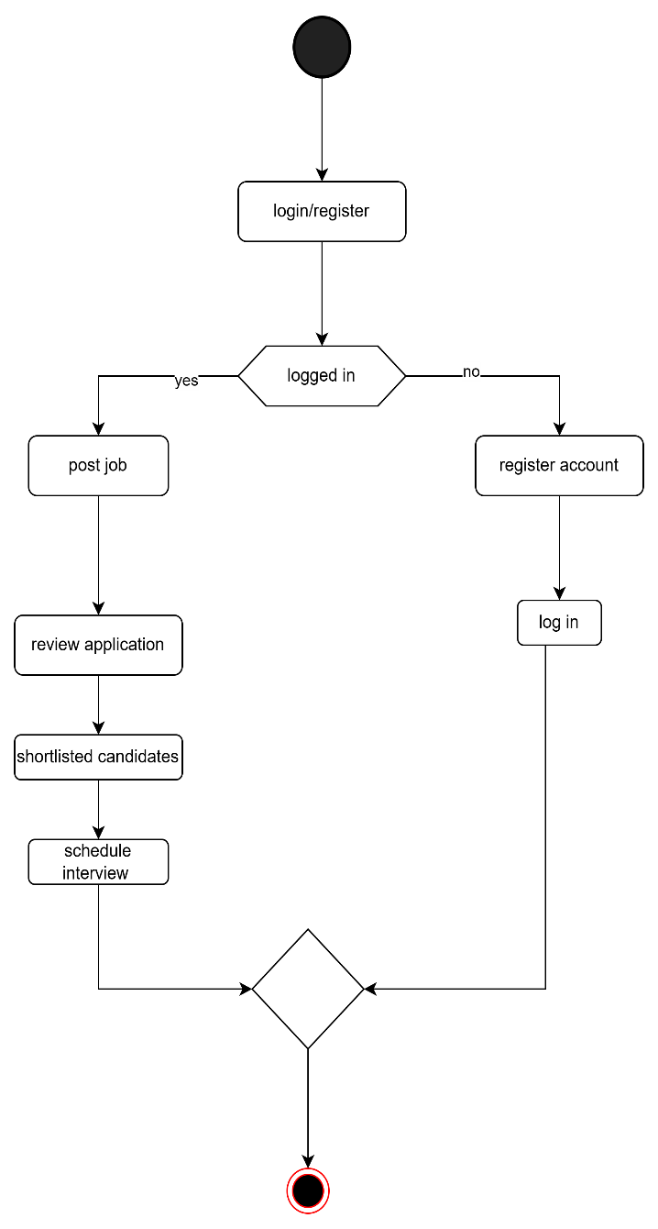

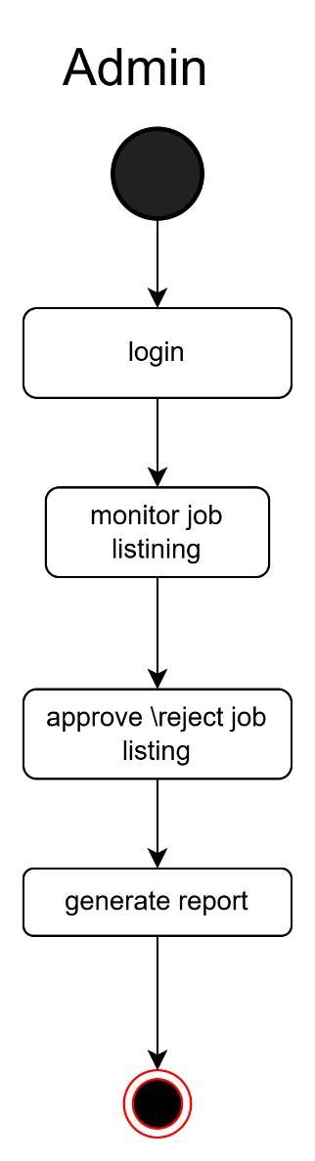

#### ****5.5 Sequence Diagram****

A sequence diagram will represent the interaction between a job seeker, the system, and the employer during the **Job Application Process**.

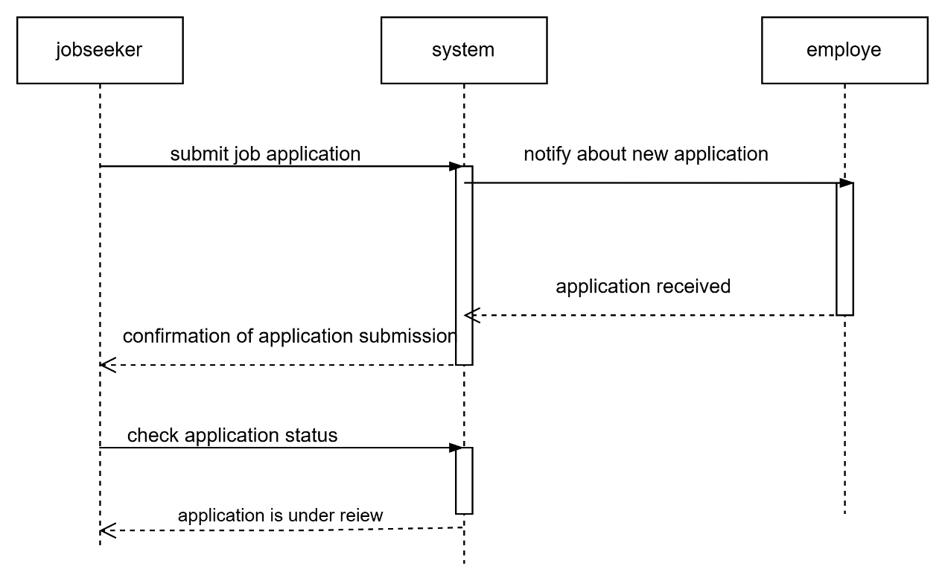

5.6 **class diagram**

1. **User** (General class for Job Seeker and Employer)
   * Attributes: id, name, email, password
2. **Job Seeker** (inherits from User)
   * Attributes: resume, profileCompletion
3. **Employer** (inherits from User)
   * Attributes: companyName, location
4. **Job Posting**
   * Attributes: id, title, description, salary, location
   * Relationships: Employer posts Job Posting
5. **Job Application**
   * Attributes: id, dateApplied, status
   * Relationships: Job Seeker applies for a Job Posting
6. **Admin**
   * Attributes: id, name, email
   * Relationships: Manages User

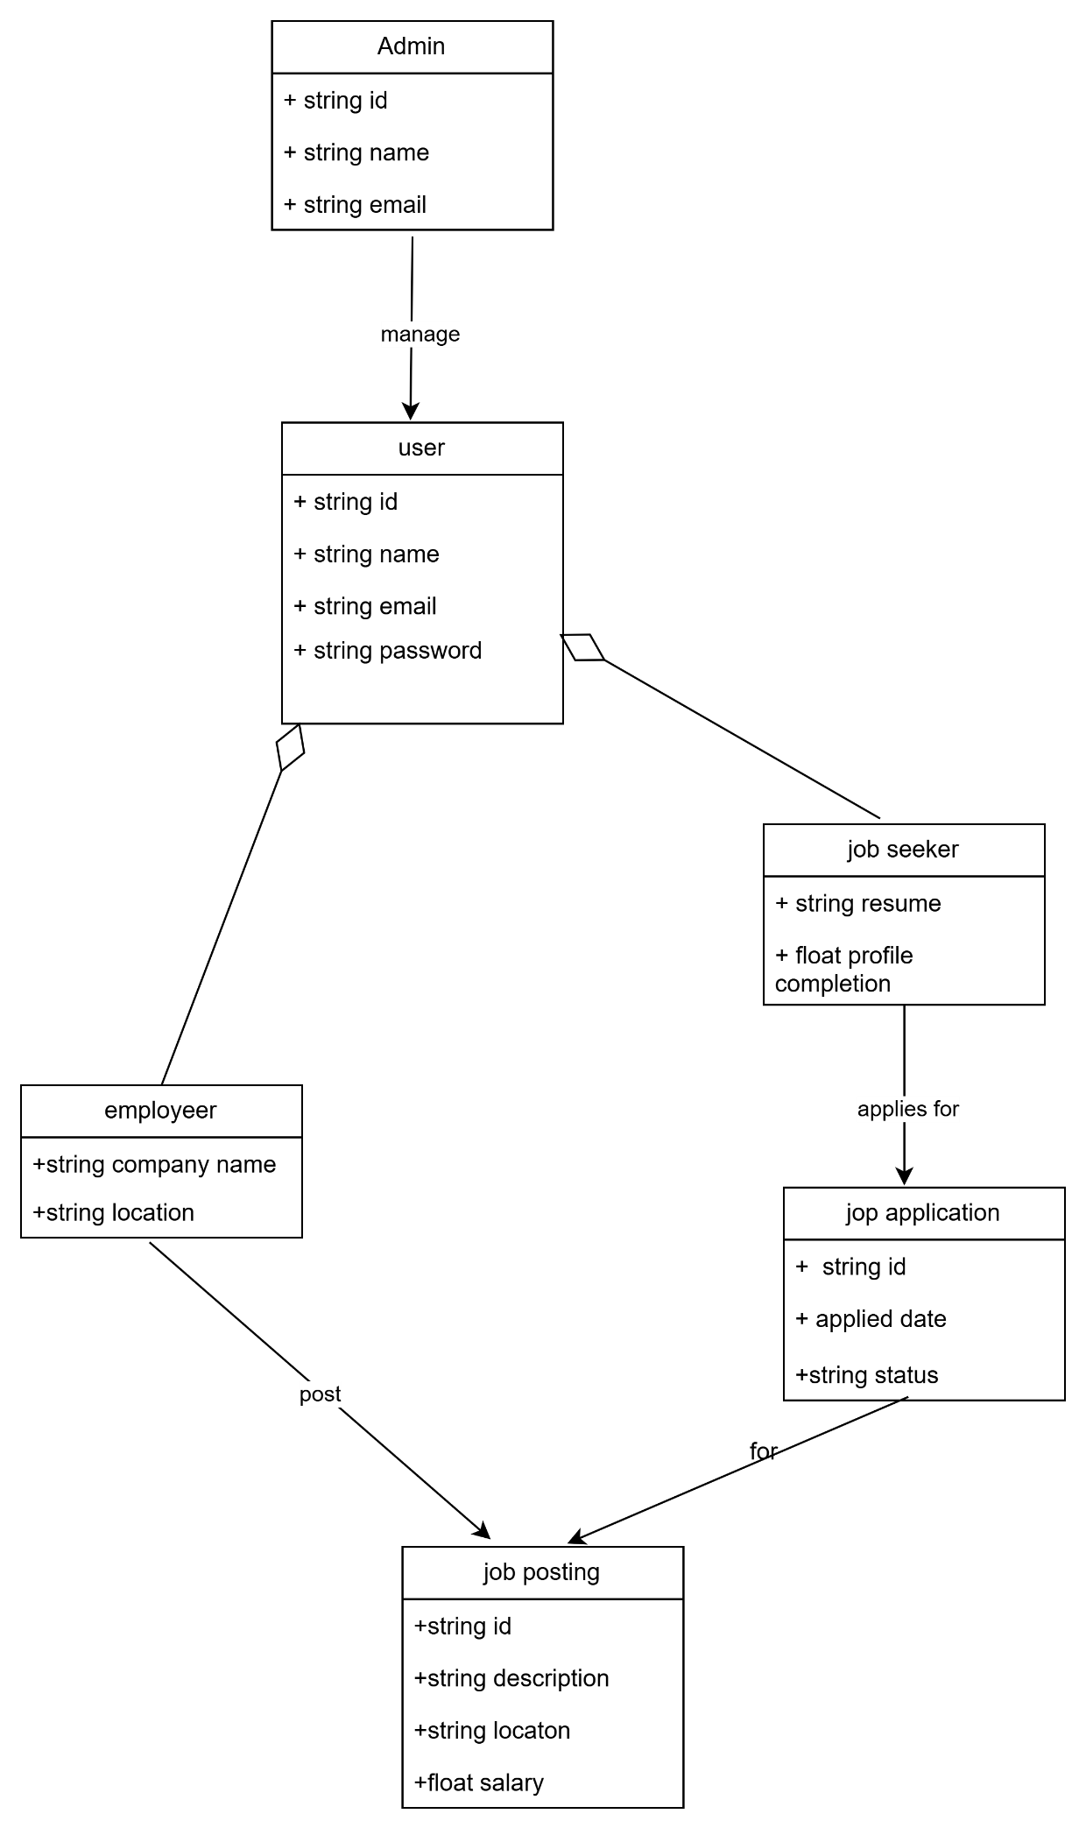

5.7 DFD

• **External Entities:**

* **Job Seeker** (Interacts with the system to search for jobs, apply for jobs, and manage their profile)
* **Employer** (Posts jobs, manages applications, and hires candidates)
* **Admin** (Monitors and manages users, job postings, and generates reports)

• **Processes:**

* **Manage Job Seekers** (Handles user registration, login, profile updates)
* **Manage Employers** (Handles employer registration, job postings, and applications)
* **Job Search & Application** (Allows job seekers to find jobs and apply)
* **Admin Monitoring** (Oversees job postings, user activity, and system reports)

• **Data Stores:**

* **Job Seeker Database** (Stores job seeker details, resumes, application history)
* **Employer Database** (Stores employer details, job postings, and application records)
* **System Logs** (Stores system activities, admin reports, and logs)

Level 0 DFD

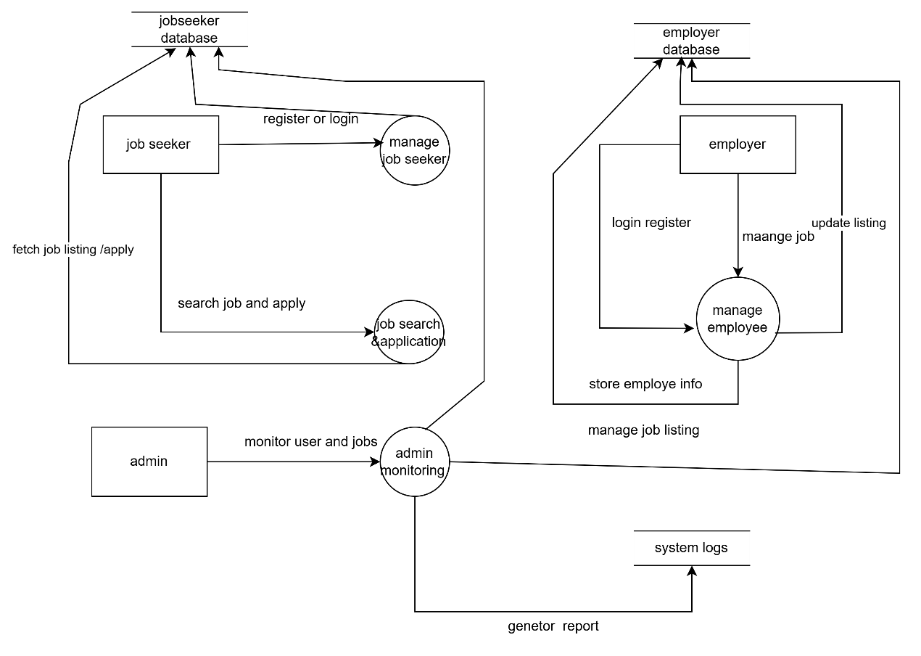

Level 1 DFD

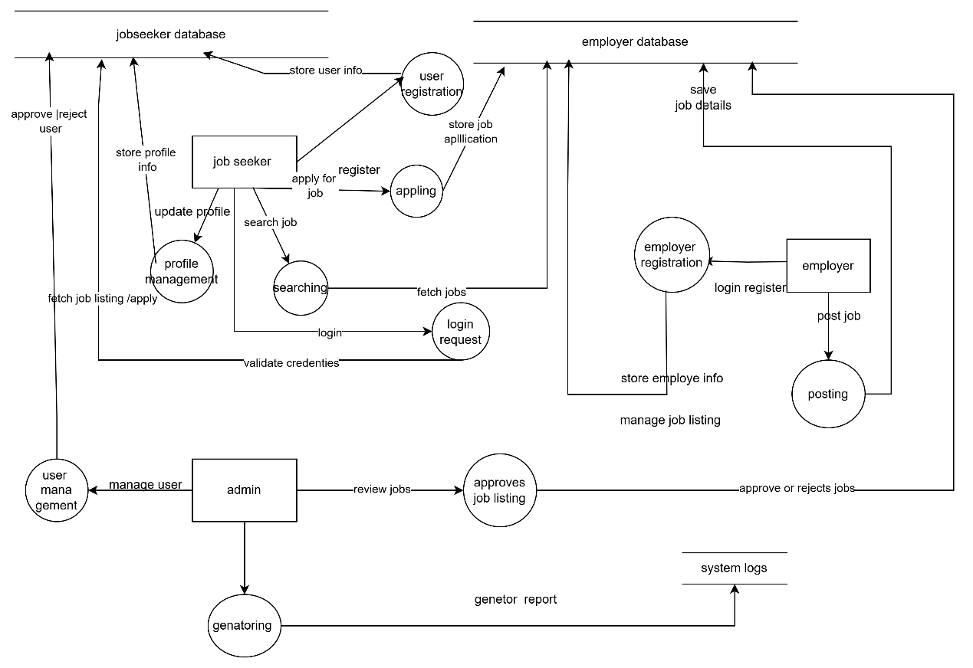

### ****6. Gantt Chart****

A Gantt Chart will be used to schedule and track the project development phases, from requirement gathering to system deployment.

(Insert Gantt Chart here)

### ****7. Appendix****

#### ****7.1 References****

* Software Engineering: A Practitioner’s Approach by Roger S. Pressman
* IEEE Software Engineering Standards